**Experiment 3**

**Aim:** Design a Door bell using push button.

**Apparatus:** Breadboard, Arduino, Resistances (470 ohm), Jumper wires, Push button, Door bell.

**Circuit Diagram:**

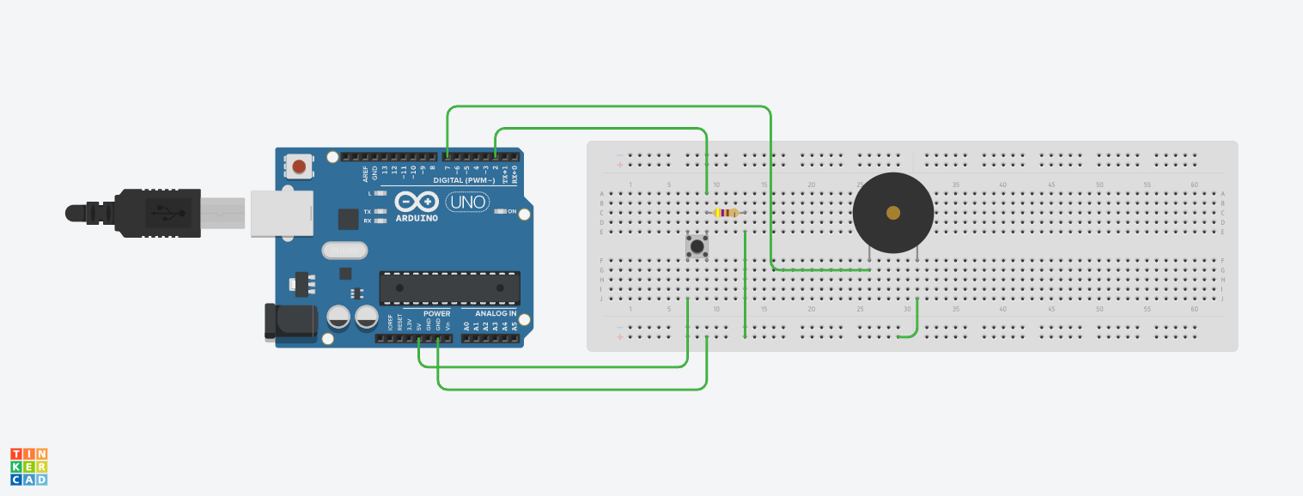

**Theory:**

1. Concept Used:
2. In Arduino, digital pins provide input as well as output but analog pins only provide input.
3. Push button gives 5V to Arduino when pressed and then Arduino give signal to bell.
4. Resistance of Arduino is less than used resistance so current through push button goes to Arduino (having lower resistance).
5. Learning & Observations:
6. Push button is connected to 5V of Arduino to provide signal to arduino.
7. Learn about different parts of Arduino and how to use them.
8. Whenever signal passes through push button, Arduino gives signal to bell to rang.
9. Bell will rang only when it get high signal and on getting low signal it does not rang.
10. Internal connection of push button.

**Problems and Troubleshooting:**

1. Making connection through push button.
2. Applying condition on push button and bell simultaneously to act.

**Precautions:**

1. Connections should be made carefully and clearly.
2. We should use resistance so that current pass through Arduino and do not go to the ground.
3. Using “if-else” carefully.
4. Use right commands for serial monitor to store, show readings.

**Learning Outcomes:**

1. Using Arduino and defining output pins.
2. Using void setup and void loop.
3. Using Serial monitor.
4. How to print on serial monitor.
5. Doing connections through push button as it have four terminals.

**Result:** Door bell using push button worked after running Arduino.